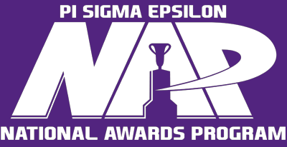

National Awards Program Competition Submission Links
Lewis F. Gordon Top Gold Chapter: https://smr.to/p107105
William H. Harris Top Silver Chapter: https://smr.to/p107112
Lloyd L. Antle Top Amethyst Chapter: https://smr.to/p107111
Marvin D. Loos Top New Chapter: https://smr.to/p107113
Most Improved Chapter: https://smr.to/p107114
Whan Challenger Award: https://smr.to/p107119
Top Management Team: https://smr.to/p107124
Top Marketing/Sales Project (Profit): https://smr.to/p107125
Top Marketing/Sales Project (Not-For-Profit): https://smr.to/p107107
Top Social Media Strategy: https://smr.to/p107117
Top Professional Development Program: https://smr.to/p107127
Top New Member Development Program: https://smr.to/p107126
Top Chapter Recruitment Program: https://smr.to/p107122
Top Project Manager: https://smr.to/p107110
Top PSE Salesperson: https://smr.to/p107128
Top Faculty Advisor: https://smr.to/p107123
Top Alumni Advisor: https://smr.to/p107116
President’s Award for Special Merit (Alumni Engagement): https://smr.to/p107108
President’s Award for Special Merit (Community Impact): https://smr.to/p107130
President’s Award for Special Merit (Innovation): https://smr.to/p107118
President’s Award for Special Merit (Inspiration): https://smr.to/p107120

